UEEN2013/UEEN2423 TCP/IP Network Fundamentals

Lab 06: Analyzing Protocols

Introduction to Protocol
A protocol is the formal specification that defines the procedures that must be followed when transmitting or receiving data. Protocols define the format, timing, sequence, and error checking used on the network. If you have 2 or more devices (e.g computers) which want to communicate, then they need a common "Protocol" which is a set of rules that guide the computers on how and when to talk to each other.

Exercise 1: Observation of ICMP and ARP

- Set up the network according to the following figure. Make sure that Packet Tracer is in “Simulation mode” (NOT “Realtime mode”) while you are constructing the network in. Just put in the IP addresses but don’t configure any route yet. All masks are /24.
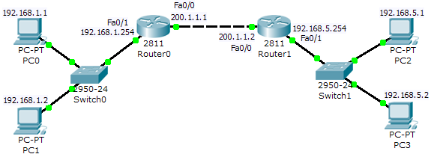

- Click on “Edit Filters”. Select only “ARP” and “ICMP”. If some of the bubbles are still red in the network, click on “Auto Capture / Play” to let some time passes, so these bubbles can turn green to indicate hardware connectivity.
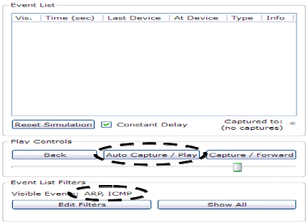
- Click on the following “envelope” icon, and then click it on PC1 and PC3 to simulate a ping. Click on “Auto Capture / Play” and observe the “movements” of packets in the form of “envelopes”.
- When the simulation has finished, a dialog box pops out. Click on “View Previous Events”. Double click on little square box of the first row of the “Event List” under “info” (next to ICMP). The dialog box shown on the following right should pop out. Try to get the “Event List” as shown in the following figure (with ICMP and ARP). Save the network file as “lab6-1.pkt”.
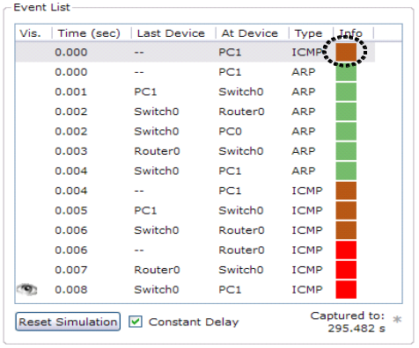 | 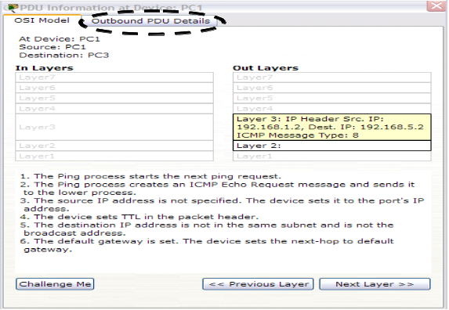

- Click on the “Outbound PDU Details” tab, and answer the following questions by referring to the information in the “Outbound PDU Details” and appendix of this lab:
  - What is the source IP address? (192.168.1.2)
  - What is the destination IP address? (192.168.5.2)
  - What is the value of the protocol field in IP header? (0x1)
  - What does this value of the protocol in part(c) mean? (protocol = ICMP)
  - What is the total length of the IP packet? (TL = 28)
  - What is value of the TYPE in the ICMP header? (0x8)
  - What does the value of “TYPE” in the ICMP header mean? (Echo Request)

- In the second line of the “Event List”, an ARP has been issued. Again, double click on the square box next to the ARP and click on the “Outbound PDU Details” tab. Answer the following questions with the help of appendix:
  - Why an ARP has to be issued? (because PC1 does not know the destination MAC address of the destination IP.)
  - What is the destination MAC address? (FFFF.FFFF.FFFF)
  - What is special about destination MAC address in part (b)? (It is a broadcast MAC address)
  - What is the value of TYPE in the Ethernet header? (0x0806)
  - What does the value of TYPE in part (d) mean? (The frame contains ARP)
  - What is the value of Hardware Type of the ARP header and what does this value indicate? (0x1 = Ethernet)

  - What is the value of Protocol Type of the ARP header and what does this value indicate? (0x800 = IP)
  - What is the value of HLEN of the ARP header and what does this value indicate? (0x6 = Length in bytes of the MAC address)
  - What is the value of PLEN of the ARP header and what does this value indicate? (0x4 = Length in bytes of the IP address)
  - From the ARP header, which device’s MAC address that PC1 is interested? (Router0)
- Double click on the square box (under column “Info) of the 4th line of the “Event List” in which the ARP data has been sent from Switch0 to Router0. The left dialog box of the following table should pop out. Click on the “Next Layer >>” and “Previous Layer <<” in order to read the description of Layer 2 of both “In Layers” and “Out Layers”. (Note: “In Layers” and “Inbound PDU Details” show the layers and frame information before the device process the frame. “Out Layers” and “Outbound PDU Details” show the layers and frame information after the device (e.g. Router0) process the frame.)
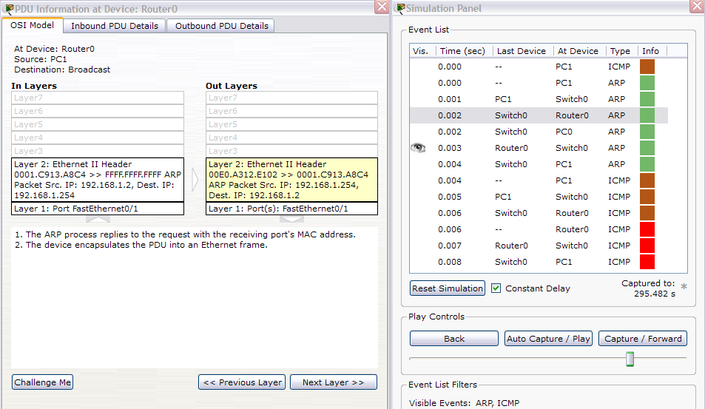

- Now, click on “Inbound PDU Details” tab (Router0) and answer the following questions with the help of appendix:
  - What is the value of the Opcode of the ARP header and what does it mean? (0x1 = ARP request)
  - What is the source MAC address? (MAC address of PC1)

- Now, click on “Outbound PDU Details” (Router0) tab and answer the following questions with the help of appendix:
  - What is the new value of the Opcode of the ARP header and what does it mean? (0x2 = ARP response or reply)
  - Which device does the destination MAC address belong to? (PC1)
  - There are similar MAC addresses in both the headers, which set of MAC addresses (Ethernet header or ARP header) will Switch0 process? (Switch0 only process the MAC addresses of Ethernet)
  - When this “Outbound” frame reaches PC1, what is PC1 going to do with the information contained in this frame? (Note: Double click on the square box of line 7 of “Event List”, the ARP frame at PC1. Click on “Next Layer >>” until the “Layer 2” is highlighted with yellow shade. Read the description, the answer can be found in the description.) (PC1 will use the MAC address of Fa0/1 of Router0 to form an entry of ARP table for IP = 192.168.1.254)

- Double click on the square box of Line 8 (ICMP of PC1), then click on “Outbound PDU Details”. Compare what you observe with the “Outbound PDU Details” of Line 1 of the “Event List” (the first ICMP). What have you observed? (Ethernet header is now present)

- Double click square box (should be red in color) on the last line of the “Event List” which is an ICMP in PC1, then click on the “Inbound PDU Details” tab. Answer the following questions with the help of appendix of this lab.
  - What are the values of TYPE and CODE of the first ICMP header? (0x3, 0x1)
  - What does the combination of the two values mean? (Host unreachable)

- Configure default routes for both Router0 and Router1. (Note: Do not switch back to Realtime mode).
Router0(config)#ip route 0.0.0.0 0.0.0.0 200.1.1.2
Router1(config)#ip route 0.0.0.0 0.0.0.0 200.1.1.1

- Now, save the network as “Lab6-2.pkt”.

- Re-open the file “Lab6-2.pkt” again. After you see all the bubbles turn to green, switch to “Simulation mode”. You should get what is shown in the following figure (Event List with an ICMP and ARP).
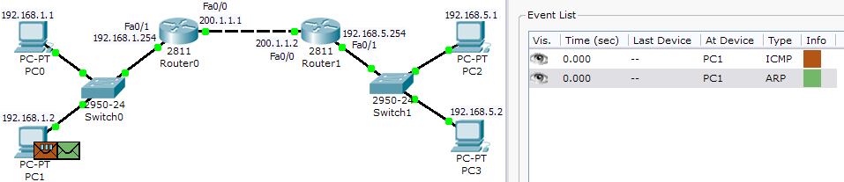

- Check the ARP table of Router0 and Router1 by typing the following command, and record what you have observed.
Router0#show arp
Router1#show arp

- Click on “Auto Capture / Play” button and observe the movements of the “envelope”.When the simulation is finished, press “View Previous Events”. You should get an “Event List” which is similar to the following figure.
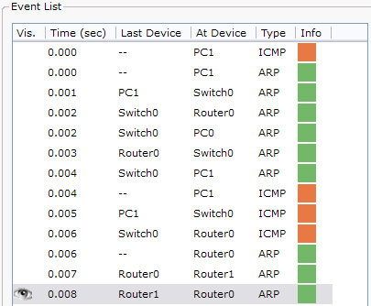

- Double click on the square box of second last of the “Event List” (Router0, Router1, ARP). Click on the “Inbound PDU Detail” tab. Answer the following questions:
  - What is the destination MAC Address? (FFFF.FFFF.FFFF)
  - What is the Target MAC Address? (0000.0000.0000)
  - What is the Target IP Address? (200.1.1.2)
- Check the ARP table of Router0 and Router1 again by typing the following command. Compare this ARP table with the previous ARP table (Ex1.15).
Router0#show arp
Router1#show arp

- Temporarily switch to “Realtime mode” and switch back to “Simulation mode”. Click on “Auto Capture / Play”.

- Double click on the square box of first ARP of the “Event List” (--, Router1, ARP). Click on the “Outbound PDU Detail” tab. Answer the following questions:
  - What is the Target IP Address? (192.168.5.2)
  - What is the source IP Address in ARP header? (192.168.5.254)

- Temporarily switch to “Realtime mode” and switch back to “Simulation mode”.

- Click on “Auto Capture / Play”, you should get an “Event List” similar to the following figure. ICMP should travel from PC1 to PC3 and back without any ARP.
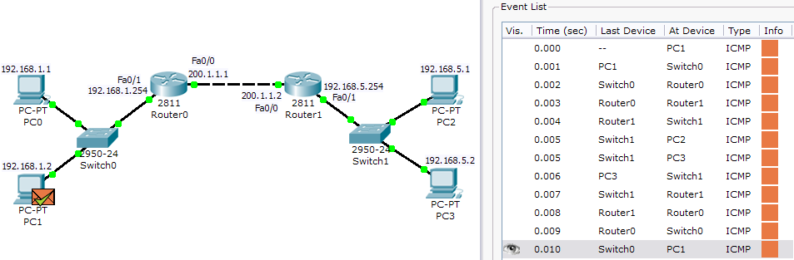

- Double click on the square box of first ICMP of the “Event List” (--, PC1, ICMP). Click on the “Outbound PDU Detail” tab. Answer the following questions:
  - What is the value of TYPE in Ethernet header and what does it mean? (0x800 = IP)
  - Which is the TTL value of the IP header? (255)

- Double click on the square box of 7th ICMP of the “Event List” (Switch1, PC3, ICMP). Click on the “Inbound PDU Detail” tab. Answer the following questions:
  - Which device does the destination MAC address belong to? (PC3)
  - Which is the TTL value of the IP header? (253)

- Click on the “Outbound PDU Detail” tab. Answer the following questions:
  - Which device does the destination MAC address belong to? (Router1)
  - Which is the TTL value of the IP header? (128)
  - Which are the values of the TYPE and CODE in the ICMP header? (0x0, 0x0)
  - What does the combination of the two values mean? (Echo reply)

- Double click on the square box of last ICMP of the “Event List” (Switch0, PC1, ICMP). Click on the “Inbound PDU Detail” tab. Answer the following questions:
  - Which device does the source MAC address belong to? (Router0)
  - Which is the TTL value of the IP header? (126)

Exercise 2: Observation of ICMP of Trace Route

Trace route is a special case of ICMP, in which the first set of ICMP packets is ICMP request with TTL=1. The second set of ICMP packets is ICMP request with TTL=2. The TTL value of the IP header is being incremented by 1 until the ICMP hits the true destination. As the first set of ICMP packets with TTL=1 reach the first router, the router will decrease the TTL by 1 (TTL = 1-1 = 0). When TTL=0, the router will drop the packet, and sends an ICMP error message back to the sender. The second router will do the same thing to the second set of ICMP packets with TTL= 2. With this process, a “route” (with all the gateway IP) is formed as the output of the command prompt.

- Click on the entry of the bottom right corner and then click on “Delete”, as indicated in the following figure.
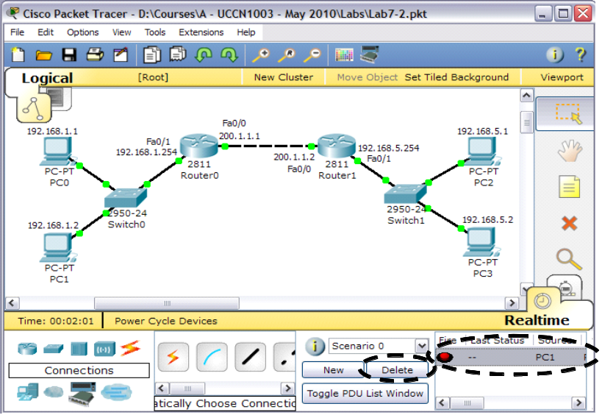

- Use PC1 to ping PC3 in “Realtime mode” (command prompt). This is to make sure PC1 is successfully ping PC3 with the ARP tables properly built.

- Click on “Simulation mode”.In command prompt of PC1, type “tracert 192.168.5.2”. You should have a similar screen as the following figure. After that click on “Auto Capture / Play”. The whole event will take a while. At the same time, observe the movement of the envelopes together with the output at the command prompt. At the end of the simulation, clink on “View Previous Events”. (If you count the entries of the “Event List”, you should have around 75 entries)
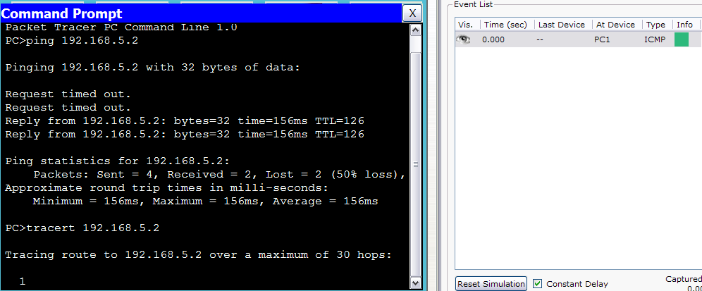
- Double click on the square box of first ICMP of the “Event List” (--, PC1, ICMP). Click on the “Outbound PDU Detail” tab. Answer the following questions:
- What is the value of the TTL in IP header? (1)
- What is the source and destination IP Address? (192.168.1.2, 192.168.5.2)
- What are the values of TYPE and CODE of the ICMP header? (0x8, 0x0)
- What does the combination of value in part (c) mean? (Echo request)

- Double click on the square box of 4th ICMP of the “Event List” (--, Router0, ICMP). Click on the “Outbound PDU Detail” tab. Answer the following questions:
- What is the value of the TTL in IP header? (255)
- What is the total length of the IP packet? (56)
- What is the source and destination IP Address? (192.168.1.254, 192.168.1.2)
- What are the values of TYPE and CODE of the ICMP header? (0xb, 0x0)
- What does the combination of value in part (d) mean? (TTL exceeded in transit)

- Double click on the square box of 19th ICMP of the “Event List” (--, PC1, ICMP), the 1st of the four square with same color after a group of three red square, as indicated in the figure. Click on the “Outbound PDU Detail” tab. Answer the following question:
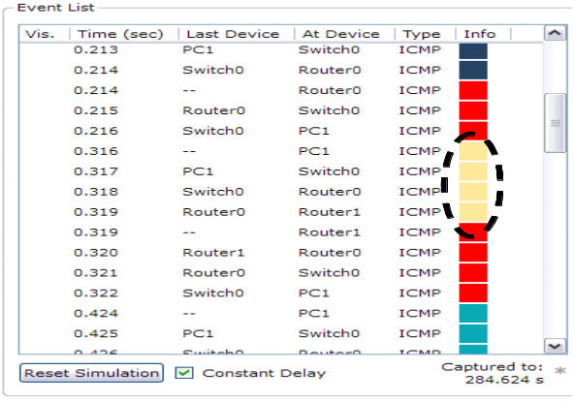
- What is the value of the TTL in IP header? (2)

- Double click on the square box of 23th ICMP of the “Event List” (--, Router1, ICMP). Click on the “Outbound PDU Detail” tab. Answer the following questions:
- What is the source and destination IP address? (200.1.1.2, 192.168.1.2)
- Which device does the destination MAC address belong to? (Router0)

- Double click on the square box of “11th to the last” ICMP of the “Event List” (--, PC1, ICMP). “11th to the last” means counting 11 steps backward from the last line of ICMP. Click on the “Outbound PDU Detail” tab. Answer the following question:
- What is the value of the TTL in IP header? (3)

- Double click on the square box to the last ICMP of the “Event List” (Switch0, PC1, ICMP). Click on the “Inbound PDU Detail” tab. Answer the following question:
- What is the value of the TTL in IP header? (126)
- What are the values of TYPE and CODE of the ICMP header? (0x0, 0x0)
- What does the combination of value in part (b) mean? (Echo reply/response)

